Schema Design
- Basic Schema with relations like:
Sales_Fact Customer_Dim
Sales_Fact Product_Dim
Sales_Fact Region_Dim
Sales_Fact Date_Dim
Returns_Fact Sales_Fact
Returns_Fact Date_Dim( as Inactive Relationship)

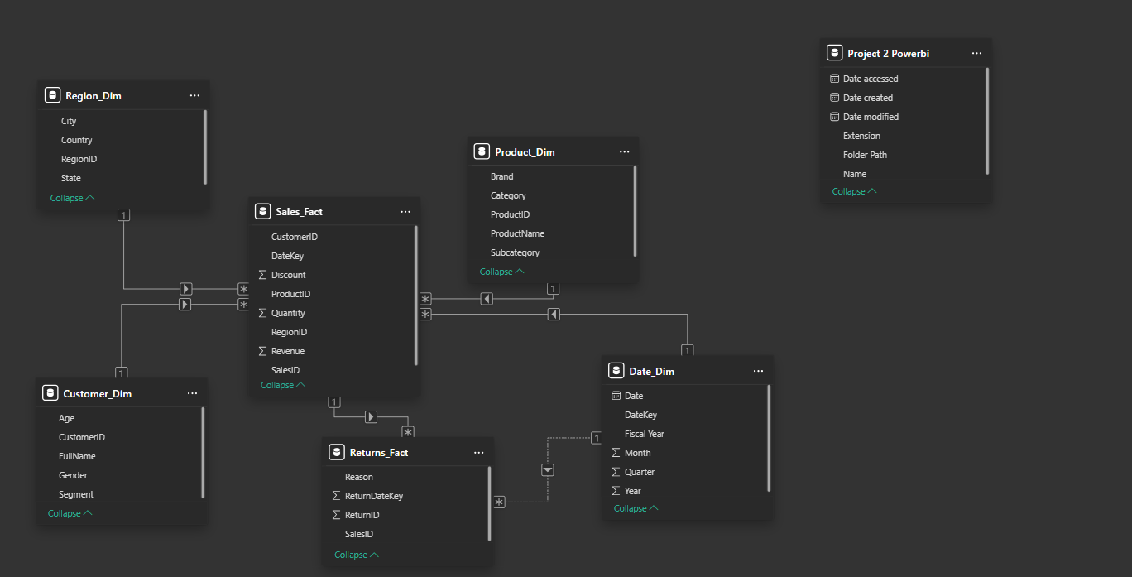

-Star Schema
- Star Schema using Sales_Fact as the Central fact table.
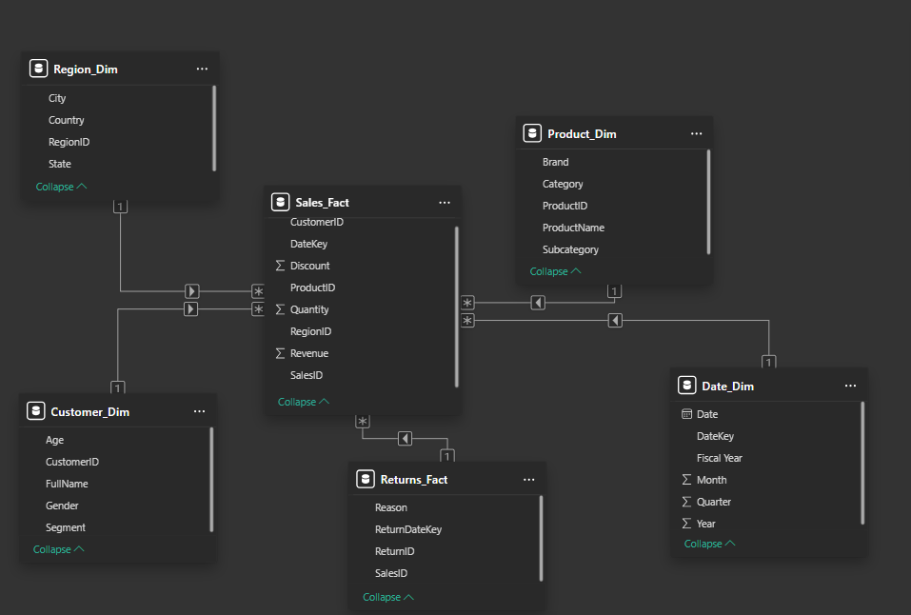
-Snowflake Schema
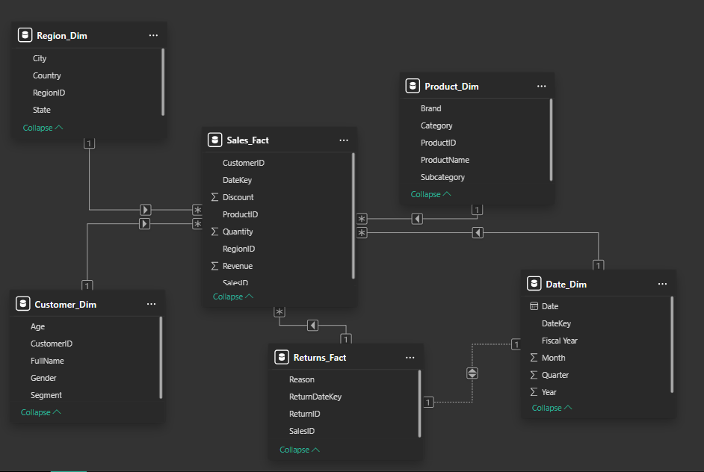
-Demonstrating Cardinalities

